1. A computer screen with a person pointing at a graph

   Description automatically generated
2. First we will talk about Risk Management. 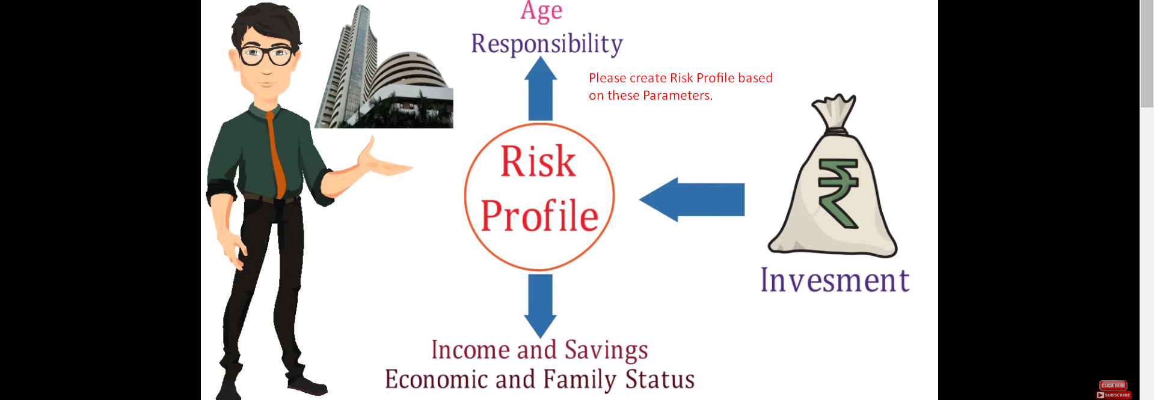 A diagram of a person in a suit

   Description automatically generated
3. The following slide is about Risk Management where mentor says that take 2% risk of the amount you want to invest in intraday.A person standing in front of a red circle with white text

   Description automatically generated
4. Let’s now talk about Risk Reward Ratio (RRR).
5. 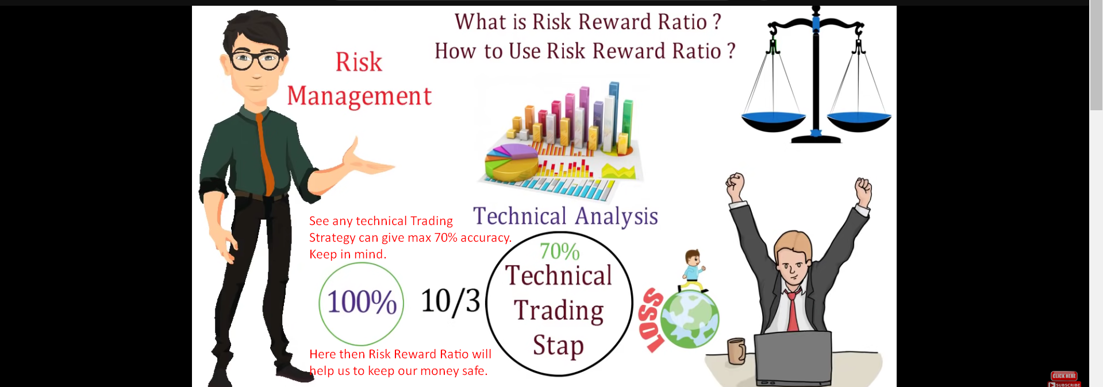
6. A screenshot of a computer

   Description automatically generated